

SHE Technical Report TR-39

**Directivity Measurements of a Panel Solar Cooker Using a Reciprocity Method**

Paul Arveson

*Director of Research,*

*Solar Household Energy, Inc.*

December 31, 2024

Citation: Technical Report no. TR-39, Solar Household Energy, Inc., (Dec. 31, 2024)

Copyright © 2024, Solar Household Energy, Inc.

Solar Household Energy (SHE) strives to unleash the potential of solar cooking to improve social, economic and environmental conditions in sun-rich areas around the world. SHE Technical Reports are intended for use within the solar cooking community, for the rapid dissemination of findings related to solar cookers. They may contain information that is based on limited data, and/or conclusions and recommendations that are solely the opinions of the author, not of the organization. Please contact the author for further correspondence.

**Directivity Measurements of a Panel Solar Cooker   
Using a Reciprocity Method**

Paul Arveson

***Abstract:*** *This report describes a method for measuring directivity of a typical panel solar cooker, the Haines model 2. A previous Technical Report, TR-27a [1] conducted a similar measurement on a Haines model 1, using a similar reciprocity method. These studies reveal the importance of Sun angle and cooker directivity on power measurements. Directivity has implications for the standardization of measurements of cooking power.*

**Introduction**  
Panel-type solar cookers, and to some extent box-type solar cookers have cooking performance that is dependent on the latitude of the location and the Sun angles during which food is cooked (or a power measurement is being taken). Only the vertical angle directivity of the device is considered here. Directivity measurements in the horizontal (or azimuthal) direction are not useful, because users are advised to turn the cooker towards the Sun direction frequently to maximize cooking power. (Parabolic cookers, of course, are intended to be aimed toward the Sun in both directions).

**Effect of Latitude on Sun Elevation**

There is a precise predictable Sun elevation (vertical angle relative to the local horizontal) at any time and location on the Earth, due to the astronomical variables that affect the Earth’s orientation in space. The Earth’s axis is tilted by 23.45 degrees from the plane of the Earth’s orbit (solar declination). The declination angle in degrees is given by [2]

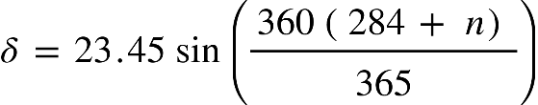 .

The Sun’s angle at a particular hour of the day is based on the hour angle *h* relative to 0 at solar noon.

Finally, to determine the local solar elevation angle ***as*** -- the angle between the Sun and the local horizontal plane, we compute



where F is the local latitude. The solar elevation angle (relative to horizontal) is ***a***s which is found by taking the arcsine.

Shown below are sample values of the Sun’s angle at noon (*h* = 0), for the dates of northern hemisphere summer and winter solstice at a range of latitudes (latitudes are negative south of the equator). Other values may be found using the NOAA calculator [3].

|  |  |  |
| --- | --- | --- |
| Latitude,  degrees | Sun Altitude, Summer | Sun Altitude,  Winter |
| 50 | 63.4 | 16.6 |
| 40 | 73.4 | 25.2 |
| 30 | 83.4 | 34.8 |
| 20 | 86.5 | 46.6 |
| 10 | 76.6 | 56.6 |
| 0 | 66.6 | 66.6 |
| -10 | 56.6 | 76.6 |
| -20 | 46.6 | 86.5 |
| -30 | 34.8 | 83.4 |
| -40 | 25.2 | 73.4 |
| -50 | 16.6 | 63.4 |

**Experimental Apparatus**

The previous experiment, as described in TR-27a, was of a Haines model 1 solar cooker that was turned on its side and rotated horizontally. This was merely a convenient means of measuring this smaller cooker. For the Haines model 2 [4], measurements were conducted in the (normal) vertical direction using a tilt table with a calibrated molding strip used for vertical angle measurements.

These are “reciprocity” experiments in which the position of the cooking pot is replaced by a light source, and the brightness of the light source is measured at a long distance. Thus, the optical lines of sight are the same as that of normal use with the Sun but reversed in direction. To achieve this, a 250-Watt incandescent light bulb was set at a position representing the center of the cooking pot (see Figure 1).

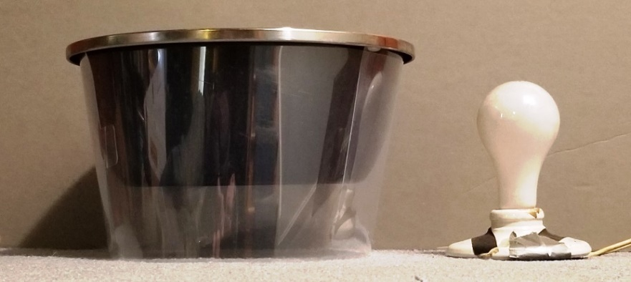  
Figure 1. Haines 2 cooking pot alongside 250W light bulb.

The light bulb was covered with a white diffuse spherical globe with a diameter of 28 cm, which is approximately the size of the cooking pot used in this cooker (Newport Coastal 7791-12W). The globe was held in place by a thin mesh net, which did not appreciably affect the brightness of the light.

A light meter (LX1330B lux meter) was placed at a distance of 10 meters and the measurements were made at night with all nearby lights off except for the device under test. The light meter was placed on a tripod and set to measure values in lux. (For these measurements we assume that the light meter is linear).

Figure 2 shows the setup with the Haines 2 reflector on the tilt table. A hinged white molding strip is visible in the back; this provided calibrated values of tilt angle every 5 degrees from 0 to 90.

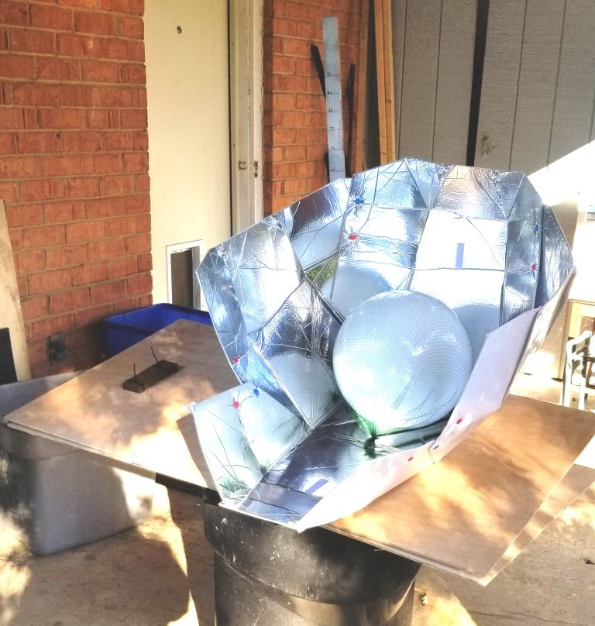

Figure 2. Apparatus as arranged on tilt table. Note angle scale in back.

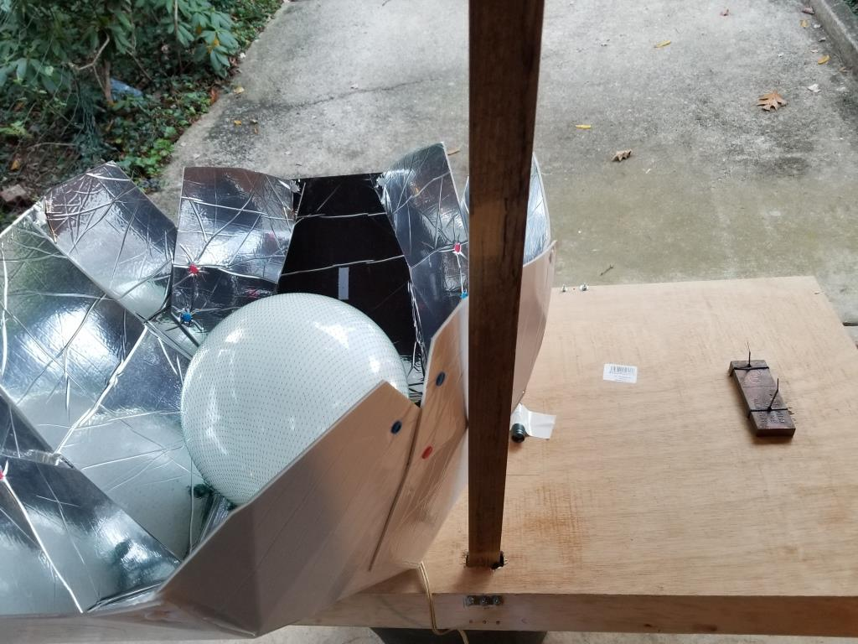

Figure 3.

Figure 3 above shows this setup from the rear, with the angle scale sticking up through a hole in the tilt table. The block on the tilt table was a counterweight.

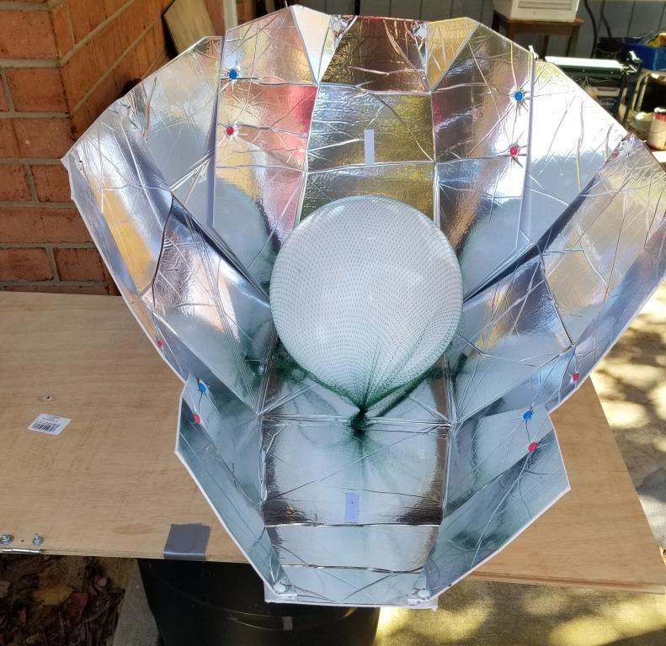

Figure 4.

Figure 4 above shows the appearance of the light globe in the cooler reflector at a tilt angle of about 40 degrees.

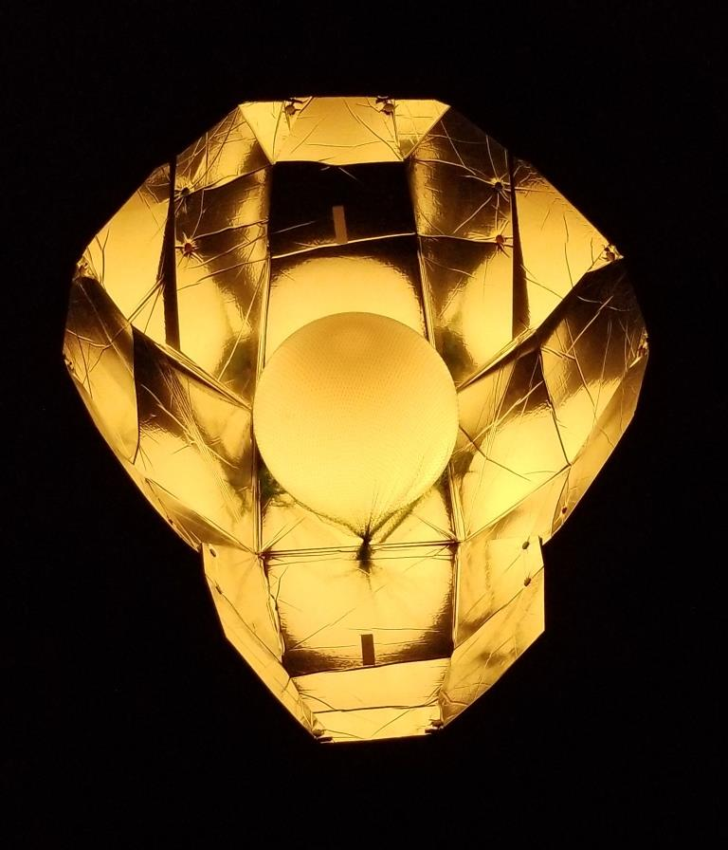  
Figure 5.

Figure 5 shows the appearance as seen at night, with only the light from the globe illuminated. Photos like these reveal regions on the reflector that are not illuminated by the light source, that is, places where the panel is not aimed at the optimum angle. Also, the globe itself appeared to have non-uniform directionality of light. This source was measured separately so that its own directionality could be subtracted.

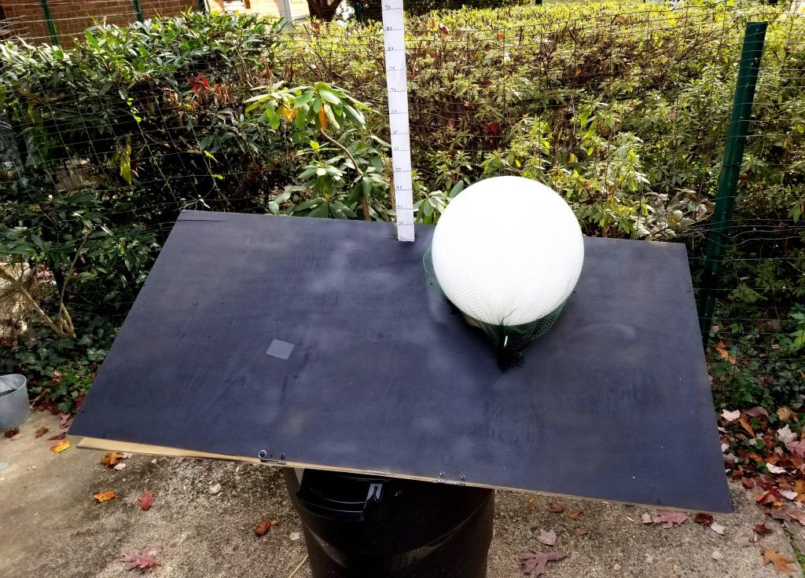  
Figure 6.

Figure 6 shows the arrangement with only the light bulb and globe on the tilt table. The tilt table was painted black and the values of light in lux were measured at night with this setup, as a function of tilt angle from 0 to 90 degrees. These values were then used to adjust the values measured with the light source in the Haines 2 reflector.

**Directivity Results: Optical Concentration Ratio**

The “optical concentration ratio” is simply the ratio of measured brightness in lux divided by the measured brightness of the globe alone on the tilt table, at each angle.

Figure 7. Haines model 2 directivity.

Figure 7 shows the results for the optical concentration ratio of the Haines model 2 solar cooker at vertical angles from 0 to 90 degrees in 5-degree steps. These data have been adjusted to compensate for the non-uniform brightness of the spherical globe.

The Haines model 2 has two settings for its reflector: a set of blue snaps or red snaps. This was intended to provide an adjustment in the directivity to accommodate lower or high solar altitudes. As can be seen, the position of the snaps made a significant difference in the angle of maximum optical concentration ratio.

**Directivity Results: Intercept Area**

In addition to measuring the optical concentration area, it would be of interest to measure the values of reflector intercept area as a function of vertical angle. This is the area enclosed by the reflector as seen from a distance at each angle. These values are of importance because they form the basis for calculating the amount of mass load to be used in the ISO and ASAE standards for solar cooker power measurements [5].

If a cooker were a flat box with no reflector, we would expect to see both types of data show a cosine directivity pattern, never achieving an optical concentration ratio as high as a well-designed panel cooker. Therefore, most box cookers have some additional reflectors to enhance concentration into the box. This will alter the directivity pattern of the cooker in some manner.

The enhanced optical concentration factor of a panel cooker is a clear benefit, but to achieve this it is necessary to know the angles of high concentration ratio, and to adjust the cooker’s angle toward the Sun direction at a given day and time. In the case of the Haines model 2, these angles are around 60 degrees for the blue snaps and around 85 degrees for the red snaps. Depending on where on the Earth’s surface the cookers are used, some adjustment in the tilt angle of the base may also be needed to optimize performance.

Of course, there are limits to the tilt angle available to prevent foods from spilling out of the cooking pot! Formulas have been calculated to show the degree of tilt angle possible in a cylindrical pot filled with liquid. These calculations are relevant to cooking with any type of cooking device, of course. A report on this subject is available in reference [6].

**Conclusions and Recommendations**

Directivity of solar cookers, particularly panel-type solar cookers such as the Haines models, is highly dependent on vertical angle. This dependence has often been neglected, which may result in sub-optimum heating performance. Therefore, it is recommended that all manufacturers of these devices should measure the directivity of their devices using a simple apparatus such as the one described here. This information can be helpful to users depending on their latitude and the time of year.

The ISO/ASAE standard for solar cooker performance has been valuable to assist in standardizing the measurement of power in a solar cooker. The current standard recognizes the importance of intercept area, but it does not include a discussion of directivity as a factor in performance. Perhaps in the next version of the standard it could do so. One option would be to simply add a measurement of optical concentration ratio to accompany the power measurement. This would provide users with the information they need for maximizing performance.

Alternatively, the solar cooker could be mounted on a tilt table for the power measurement and adjusted to maximize the optical concentration ratio. However, such a measurement might be problematic, because the load is water, and tilt angles affect the geometry of the cooking pot as well as the cooker. It may prove impossible to conduct the measurement without spilling the load.

For further research, it would be helpful to quantify experimentally the relationship between optical concentration ratio, intercept area and cooking power for various solar cooker designs.

**References**

1. Arveson, P. “Procedure for determining the directivity of a solar cooker”, TR-27a, June 6, 2017 (rev. June 9, 2018). <https://www.she-inc.org/wp-content/uploads/2018/05/TR-27a-Procedure-for-Determining-the-Directivity-of-a-Solar-Cooker.pdf>., “

2. Martin, C. L. and Goswami, B. Y., “Solar Energy Pocket Reference”, Intl. Solar Energy Society, ISBN 0977128202 (2005).

3. NOAA Solar Calculator, Global Monitoring Laboratory, <https://gml.noaa.gov/grad/solcalc/>

4. Haines Solar Cookers, <https://hainessolarcookers.com/>

5. “Testing and Reporting Solar Cooker Performance”, American Society of Agricultural and Biological Engineers, ASABE S.580.1, Nov. 2013. <http://www.asabe.org/media/200979/s580.1.pdf>

6. Arveson, P., “The Tipping Pot Problem”, <https://www.washacadsci.org/Journal/Journalarticles/V.104.1a.pdf>