**Solar Cooker Project for Kakuma Refugee Camp, Kenya**

**by: Solar Household Energy, Inc., Washington, D.C.**

**April, 2022**

This project will provide materials to make ten Haines 1 Pop-Open Solar Cookers and ten days of solar cooking training for ten women in Kakuma Refugee Camp, Kenya.

**Solar Household Energy, Inc.,** <https://www.she-inc.org/>, is a Washington, D.C.-based NGO promoter of solar cooking in developing countries. Bethesda Rotarian **Paul Arveson** and San Diego Rotarian **Roger Haines** are Board members of SHE.

**The Cooker**: The Haines 1 Pop-Open Solar Cooker is a larger, more powerful version of the original Haines 1, and is made by Haines Solar Cookers LLC, a San Diego, California, company whose partners are members of the **Rotary Club of San Diego**. Over 4,000 Haines Solar Cookers have been sold on Amazon, and the Haines 2.0 SunUp solar cooker has been rated “best” solar cooker by two indepen­dent rating organizations. See: [www.HainesSolarCookers.com](http://www.HainesSolarCookers.com). Cookers should last 5-10 years.

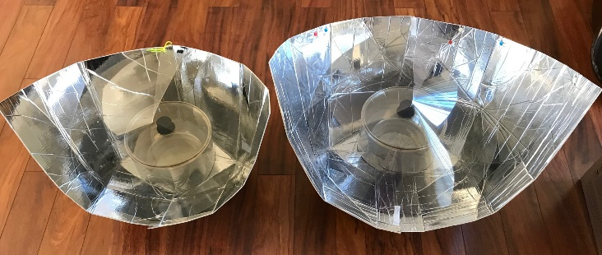

**35% more powerful**. The reflector for new Haines 1 Pop Open Solar Cooker is 1/3 larger than the original Haines 1 (9800 cm2, compared to the original 7200 cm2). And tests show that it is about 35% more powerful. So it reaches cooking temperature faster, and “tops out” at a higher temperature for baking. Original Haines 1 Haines 1 Pop Open

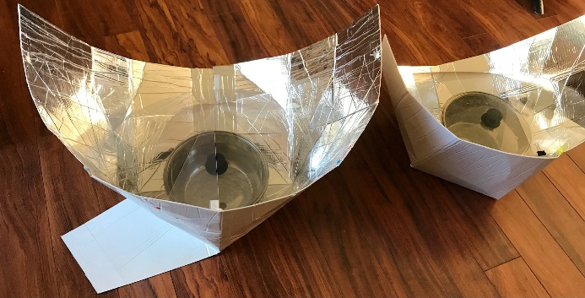**Pops Open.** The reflector “pops open” immediately for use, with no snaps or grommets.

**“Hold-down” flap**. The new reflector has a “hold-down” flap in the back. Placing a rock on the flap holds the cooker stable in windy conditions.

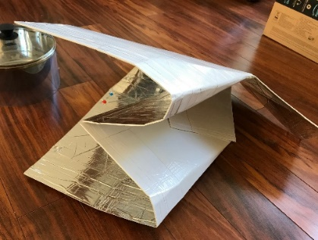**Folds up after use.** First, push the bottom Haines 1 Pop Open Original Haines 1   
center of the reflector **↓** upward.

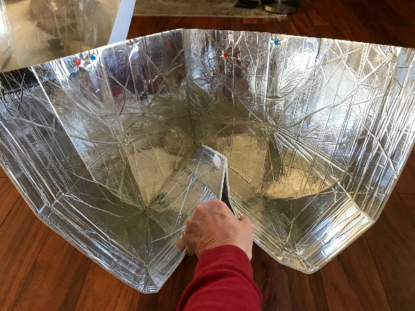

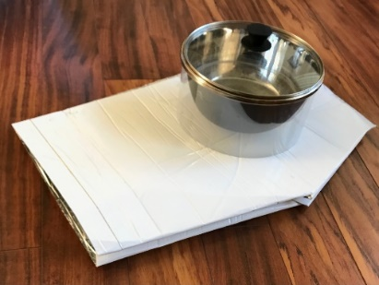As the center folds up, press the sides of the cooker together until the folded reflector lies flat.” **→**

To use the cooker again, simply toss it on the ground and it will “pop open,” ready for use.

Use the clear **cooking sleeve** to elevate and insulate the cooking pot.**→** Attach the **circular cover** with velcro loops to hold the reflector in the proper parabolic shape, as shown in the top photos.

**The Materials**: The materials to make the new cookers are already in Kakuma and will be provided free by Haines Solar Cookers LLC. The reflector material is Mylar bonded to foam insulation with a strong plastic backing. It does not scratch or oxidize and is impervious to boiling water.

**The Makers**: The materials will be made into cookers by refugees in the Youth Education Development Association (YEDA), <https://m.facebook.com/yeda.org/?locale2=en_GB> in Kakuma Refugee Camp, Kenya. YEDA will also make **carrying bag**s for the cookers, using locally-sourced materials in the Camp.

**The Trainers:** The trainers will be **Camily Ramonyi** and **Grace Chepkemei**, both members of the Rotary Club of Eldoret, Kenya), who have been teaching solar cooking for many years.

**The Curriculum**: The trainers will use a ten-day curriculum for solar cooking developed for this project by the Solar Education Project—**Mary Buchenic** (Rotary Club of Hubbard, Ohio) and Jennifer Gasser. The curriculum teaches the science behind solar cooking as well as how to cook local foods using the Haines 1 Pop-Open Solar Cooker. See: <https://gdsnonprofit.org/solar-education-project>. At the end of the training, participants will be awarded a Certificate in Solar Cooking, and will be able to train others.

**The Cooking Pots**: Ten Haines stainless steel Dutch ovens with glass lids will be provided free by Haines Solar Cookers LLC.

**The Insulated Baskets**: People are more likely to use a solar cooker if they can cook the evening meal and keep it hot until after dark by placing the pot in an insulated basket. Grace Chepkemei will provide training in how to use these insulated baskets, which will be made from locally-sourced materials for the project.

**The Evaluation**: At the conclusion of training, participants will fill out questionnaires evaluating the Haines 1 Pop Open Solar Cooker, and solar cooking in comparison with their usual methods of cooking. Participants will keep their cookers, and we will make periodic follow-up visits on sunny days to evaluate whether the cookers are still in use. An full evaluation report will be provided to all parties and funders.

**The Budget: 10 Solar Cookers and Trainees**

1. **Materials** to make ten Haines 2.0 “Pop-open” Solar Cookers Provided by HSC
2. Cooking **pots** (black) with glass lids (9 + one ”stacked” set. Provided by HSC
3. **Trainers (incl travel and per diem)** $600
4. **Insulated heat-retaining baskets** ($8 ea. made locally) 80
5. Simple rectangular cloth sewn **carrying bags** ($2 ea. made locally) 20
6. **Labor** to make 10 Haines 1 Pop Open cookers ($15/cooker) (YEDA) 150
7. **Per diem** for ten focus group members ($1/day x 10 days x 10 women) 100
8. **Uncooked Food** for ten group members ($1/day x 10 days x 10 women) 100
9. **Contingencies** 50

**Total:**  **$1,100**