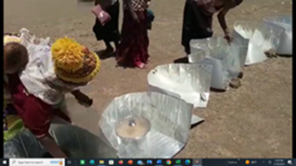
Haines Solar Cooking 10 Day Focus Group Follow Up. Kakuma Refugee Camp
PROGAM DATES TOPIC
10 Day Focus Group May 22, 2022, to June 1, 2022, approximately 1,584 total project hours 7 day solar Haines cooker training (Camily)
3-day heat retention basket training (Grace)
1-day preliminary meeting @ YEDA (Bruno)
Food, supplies, ovens (Haines Donation), and stipends
$1,665.00 (10 Day Focus Group)
Prep/Instruct/Manage March 15, 2022, to Present SEP, Project Management and Support (600 hrs) WhatsApp Follow Up May 30, 2022, to Present Kakuma Group Support - SEP Follow Up

11 MONTH FOLLOW UP April 15, 2023 Review, survey, and update (Mlasi and Martha)
Prep, meet, shop, set up, and facilitate/80 hours.
SHE SEP
Stipends/Fees $220.00 $110.00
Data Bundles $140.00
Food $350.00
Transport $ 30.00
Copy Materials $ 55.00
$ 600.00 $305.00
Follow Up Total: $905.00
PROJECT TOTAL: $2,570.00 USD
PARTNERSHIPS: Solar Household Energy: DC
Youth Education Development Assoc (YEDA), Kakuma Kenya
Haines Solar Cookers, Roger Haines: CA
Solar Education Project, OH
PROJECT DESCRIPTION
In the Kakuma Refugee Camp was established in 1992 in Northwestern Kenya and houses almost 200,000 people. As one of the largest refugee camps supporting families from South Sudan, Somalia, Ethiopia, Burundi, Eritrea, and the Democratic Republic of Congo, Uganda, and Rwanda. The climate is not well suited to agriculture, however, sporting almost 300 sun filled days each year.
The Haines pop open solar oven focus group program was initiated and designed by a SHE/SEP/Haines collaborative program, designed and implemented with a focus on long term impact, accountability, continuous improvement and to introduce a sustainable and environmentally friendly, renewable cooking method. Eleven trainees were selected by the YEDA Manager to participate and receive a Haines Pop Open Solar cooker and heat retention basket in a 10-day focus group training. The trainees agreed to remit photos of foods cooked, share recipes, and their journey during the 6 month follow up period. At the 11-month mark, the group was able to meet, cook together and share their solar cooking journey.
The event was held on April 15, 2023, at a church compound in Kakuma 3. Ten of the eleven women were present. The 11th woman reported, through her husband, that she was seven months pregnant and lives in Kakuma 2 (too far to ride or walk), and therefore not able to attend. She agreed to complete the survey later and sent her daily cooking logs.
Two of the three elected officers organized the project, made a list of the groceries needed, shopped, and set up the event and took photos. The Chairwoman paid each woman a 1350ks at the end of the day. The group cooked Chicken and Rice Pilau and Spaghetti. The extra food was divided among the participants, and a small bag of extra rice, vegetables, and spaghetti were sent home for the next meal. The black painted sufuria pot and lid were used in each of the 10 cookers and appeared to be in good condition.
The event was held from 9:00 am to 3:00 pm. The first hour was a review of the survey questions and solar cooking review with a short question and answer with Mary and Jennifer/SEP. Grace/SEP @St. Joseph’s facilitated the meeting, the group sang a welcome song, introduced themselves and participated in the food preparation and cooking. The food was put into the cookers at 11:00 am in full sun and took almost 2 hours to cook. The food was enjoyed as a group with their families and shared with others nearby. All participants were appreciative of the extra food and stipend.
In this report, we evaluate the success and impact of the Haines Solar Cooker Focus Group solar and heat retention basket program in Kakuma Refugee Camp in Kenya. SEP explored the main factors that contributed to the program's success, challenges encountered, and future suggestions.
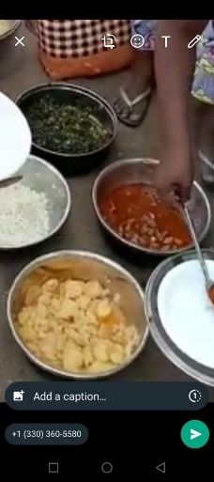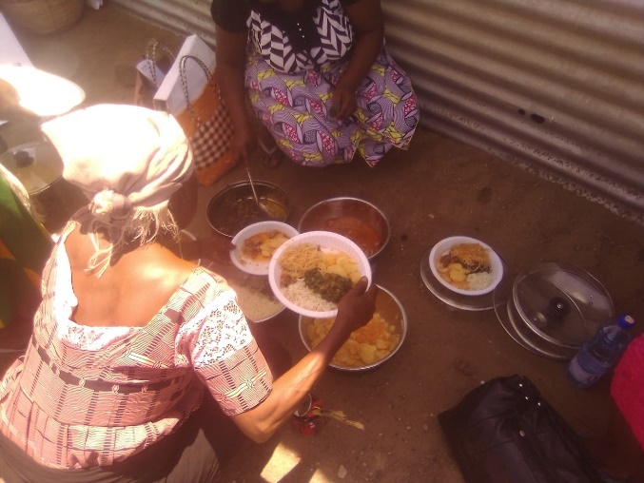

PROGRAM SUCCESSES
The solar cooking program in Kakuma Refugee Camp had several factors contributing to the overall success and positive outcome. The people influencing the project’s leadership were SEP’s Jennifer Gasser and Mary Buchenic and the solar cooking facilitator Camily Wendende Ramonyi and Insulated Basket facilitator Grace Chepkemei Rono. The stakeholders were Solar Household Energy and Haines Solar Cookers.
Goal: Using locally sourced materials and human capital, provide training, support, and follow to a group of ten refugees, using the Haines Pop Open Cooker (and heat retention basket) in the Kakuma Refugee Camp, for a period of one-year, and by doing so, reduce dependence and cost using wood and charcoal as fuels.
- Solar Cooker 10 Day Training provides all supplies, food, materials, education, and support to create successful solar cooks using the Haines 1 pop open solar reflective panel cooker (and the insulated basket).
  - The program provided training to eleven women, ten from Kakuma 3 and one from across the river in Kakuma 2, (the YEDA Office Manager also received and oven and sat in on the training). All who learned how to use solar cookers efficiently and effectively, received a Haines pop open oven. 100 percent of the women trained continue to use their solar cooker on a regular basis after almost 1 year. 73% of the trainees sent photos of foods cooked through the WhatsApp group for the first six months. 100% of the trainees completed the 11-month survey update. 100% of the women agree that using the solar cooker has reduced their charcoal and wood use.
  - One of the women reports using her solar cooker every day the sun is shining. Her husband is involved with solar cooking and uses her oven for demonstrations in Kakuma Two.
  - Six of the women report using the solar cooker 4 to 5 times a week (weather permitting), three of women report using the solar cooker less than three times a week, and one had the pot stolen and didn’t solar cook until she found a replacement (she is solar cooking again 4 to 5 times a week). *This information was received after the meeting. There are days that they do not have food to cook, and they eat leftovers, eat bread or nothing. 100% of the women took 2 quarts of rice, an assortment of vegetables and the leftover spaghetti home.
  - Each training workshop had a native language facilitator, written training materials, photographer with instructions on how to photo journal, scribe, or stenographer to write on the board or help participant complete survey and paperwork, and a schedule for follow up and timeline.
- Materials Purchased Locally: One of the objectives was to purchase all materials, food and supplies locally and utilize people in the region for training.
The refugees received food, solar cookers, pot with lid, and a heat retention basket. All food was purchased from the Kakuma Camp Market and transported by local motorbike taxi to the compound. All solar cookers and baskets were assembled in Kakuma, by the trainees, utilizing supplies stored in Kenya by Haines, and sent to YEDA to be assembled by the group. The baskets and liner material were sourced in Eldoret, Kenya and transported by the facilitator.
- Health benefits: The adoption of solar cooking reduces the use of charcoal and wood, which can cause respiratory and other health problems. The solar cookers do not produce harmful emissions, which makes them healthier and safer for the users. By reducing the dependence on fossil fuels and traditional cooking methods, the program has improved the health and well-being of the refugees, particularly women and children.
100% of the trainees agree that they use less charcoal and firewood than before receiving the solar cooker. 75 people are fed by the 11 solar cookers. The cost per person to cook with charcoal and wood on the baseline survey was 276 ksh ($2.01 usd) and after the 11 month follow up, the cost of fuel used per week person was 185 ksh ($1.35 usd). A savings of 91 ksh (.66 usd) per person fed.
Most of the women of the group indicated, although they used less charcoal after receiving the solar cooker, they purchased the same size bags each month. Due to the charcoal shortages, and the upcoming rainy season and having large families that required multiple pot cooking. The families sell unused charcoal and wood.
- User satisfaction: The women participating in the program were satisfied with the solar cookers, and pots received. Each made their own oven in May 2022 and were in good condition eleven months later, each received all of the equipment important to becoming a successful solar cook (cooker, pot with lid, polycarbonate sleeve and wind shield).
The women appreciated the ease and portability of the Haines Pop Open oven. It is lightweight and easily stored, when not in use, inside of the heat retention basket. The black pots are showing wear; however, they can still be used with the solar cooker. The size of the pot is approximately 4 - 5 quarts.
The women expressed a desire to be involved in other programs and receive a second solar cooker to increase the volume of food they can cook for one meal. The women have families of 3 - 10 people and cook once a day, weather permitting.
- Integrated cooking solutions: The heat retention baskets were a fuel reducing solution to cooking during less-than-ideal weather conditions for solar cooking.
The heat retention basket is a simple and effective technology that can be used to cook food in a low energy and sustainable way and the women appreciate having the opportunity to keep one pot warm until the food is served. Introducing the heat retention basket with the solar cooker reduces the amount of charcoal andwood used to cook food.
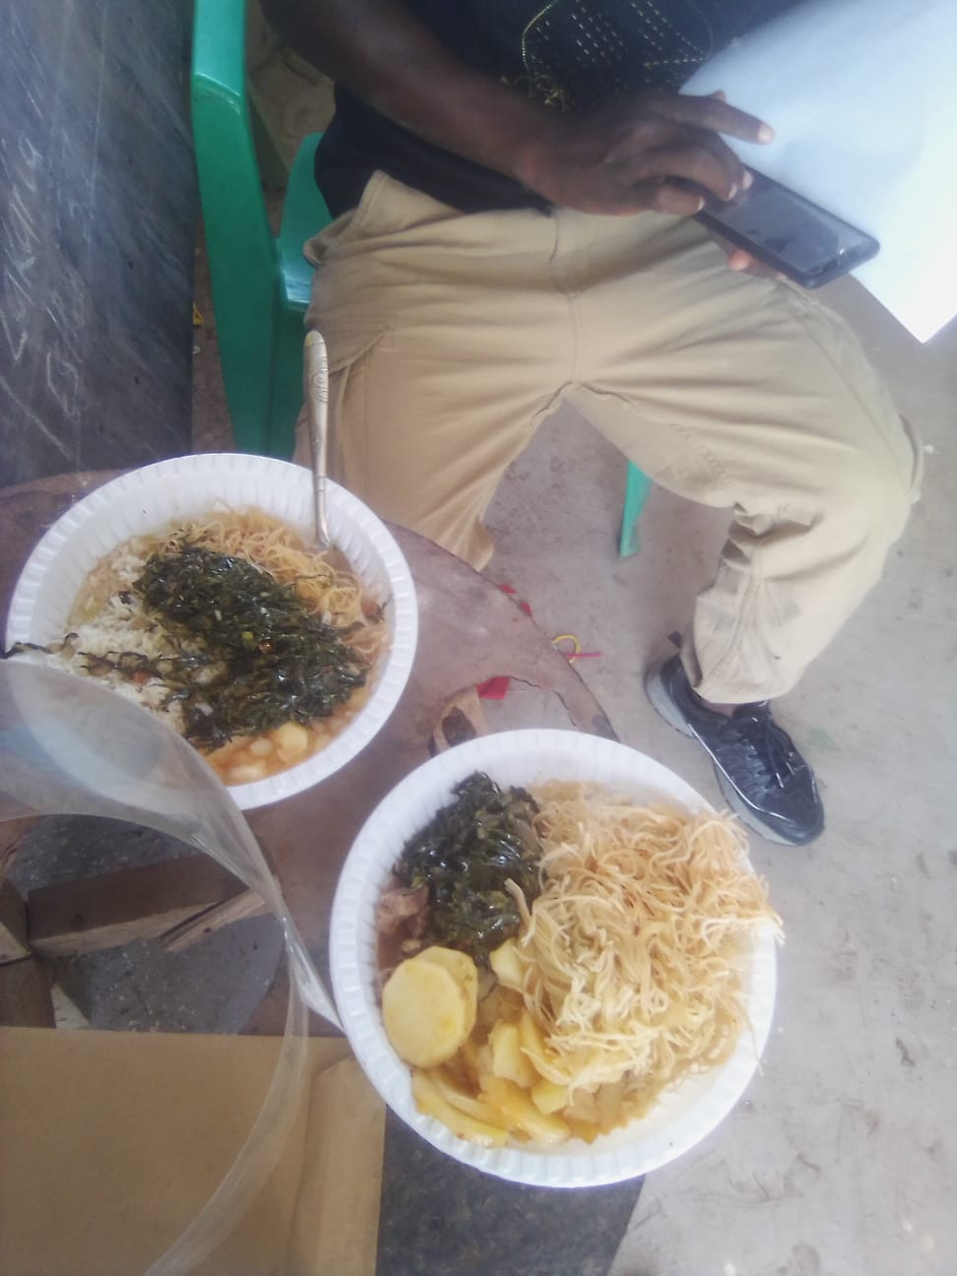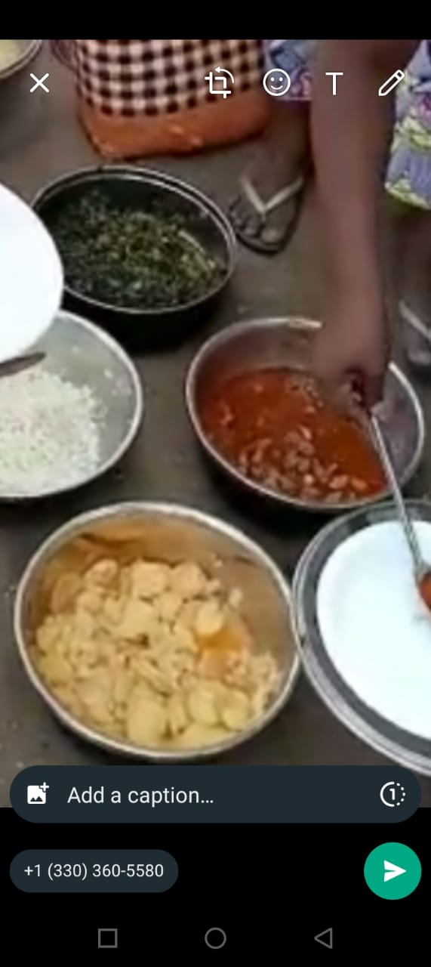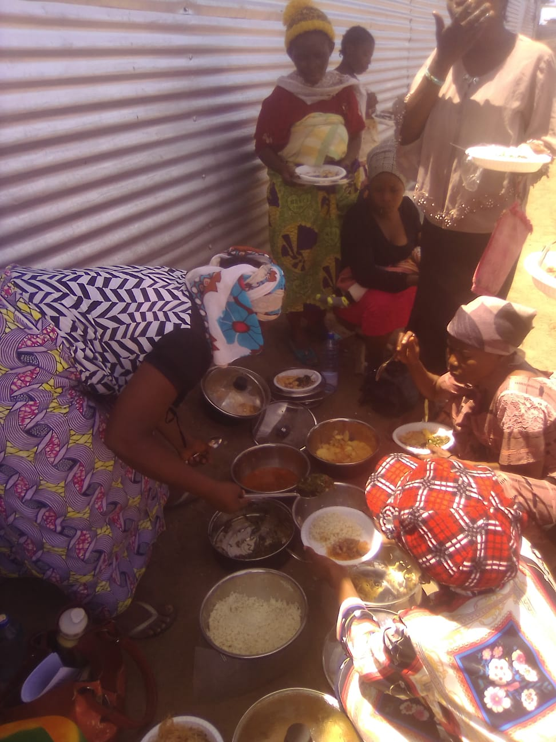

PROJECT CHALLENGES:
Despite the program's overall success for the first year, the challenges encountered are noteworthy:
- The main challenge was long term program funding. According to the project leader (Mlasi), the lack of funding created uncertainty about the program's future and the ability to expand the education and solar ovens to other local women. There was no funding for data bundles to share photos or worksheets and no food stipend.
  - The group suggested a monthly stipend for the group to gather and cook together and purchase data bundles to share their solar cooking successes.

- Cell Phone and Wi-Fi: Although 73% of the women submitted photos, they admit to having to use a family member’s or friends’ phone to do so, and data was costly. Only 18% of the trainees have access to Wi-Fi, and a smart phone with data is not the norm. Of the 11 women, 1 had her own smart phone with data, 1 had her own phone with no data plan, 4 had access to a phone (but no data bundles), 4 had access to a phone with no data plan, and 1 had no phone or access to any technology. None of the women had access to a computer or tablet.

  - Cell Phone with data plan: Most of the eleven women share cell phones with other women or their husband. Having access to a cell phone or a computer with data was non-existent. We added data bundles to the budget for planning purposes and to continue communication.
  - The mpesa account (funds) is attached to the phone, therefore making funds transfers challenging. SEP utilizes the terrorist watchlist to protect our trainees and funders from known problems, however, transferring funds for the project were transferred to two unknown mpesa accounts. In both cases, the money was made available to our Chairwoman and her assistant. The budget and product costing were affirmed in advance.
  - The secondary issue regarding cell phone use is related to data collection, photos, videos and support via WhatsApp or email. 98% of the women do not have a cell phone with data and 100% of the women do not have email accounts, since they have no way of receiving emails without going to the data café. The facilitator and assistant generated email accounts, however, could not send the survey forms since there were no scanners available.

  - The women suggest a small monthly stipend to help the women with food and Wi-Fi/phone data to transfer information and gain support.

- Communication is difficult without a known, and well-liked interpreter. It requires a high level of trust from the women to speak comfortably through a male interpreter.
  - The women had daily responsibilities at home which removed them from training for long periods of time. The women attended daily for the majority of the 10-day focus group, and 10 of the 11 trainees returned for the follow up meeting.
  - The language and literacy challenges were problematic during the survey and data gathering. The data collection sheets will be simpler for the next workshop, and will include photographs, icons, and drawings.
  - During the 11 month follow up meeting, we added a woman interpreter that was familiar to the group. Grace was the facilitator from the 3-day basket workshop. The group will try to meet one Monday a month to better support each other.

- Cooking for large families: In refugee camps, cooking may be for more than one family. The total number can be 7 to 10 people and use several pots to cook.
  - One sufuria pot appears to be 3 to 4 quarts (US). One solar cooker (with one pot) may not be able to meet the cooking demands of a large family, and women may still need to supplement their cooking with charcoal to ensure that they can cook enough food for everyone. Several of the women commented that the solar cooker was great, however, one pot was too small to cook for a family of 5 or 6.
  - SEP is investigating the possibility of each women receiving a second solar cooker for large volume cooking and training others.
  - Watch videos of cooking with the haines solar cooker and foods purchased/
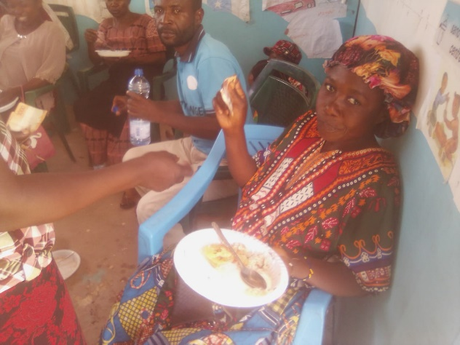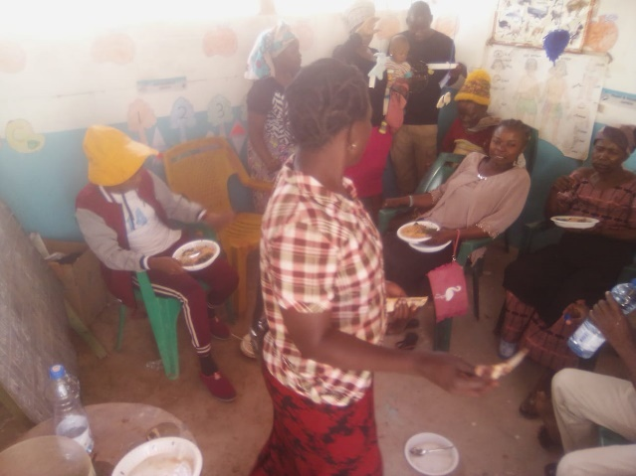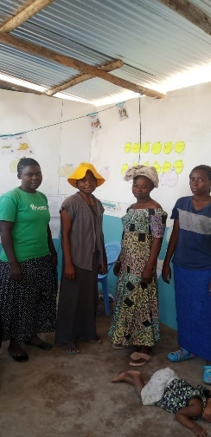
FUTURE CONSIDERATIONS:
- Youth Voice: Utilizing solar cookers as teaching tools in schools, churches, women’s community groups and orphanages allows for hands on learning and practice with youth. The small group training encourages small group support to better learn HOW the solar cooker works, and practice the maintenance, care, and repair of the cookers. Encourage the training of families and small groups within communities to act as trainers and educational resources for future projects.
- Incorporate women's leadership: Community involvement and consultation in the selection process of program participants to ensure inclusivity, and that the program meets the specific needs of the community. The baseline survey was not the place to begin. A conversation about current cooking methods. The long-term acceptance and use in the community will increase when funding support continues throughout follow up. The women liked the idea of shorter 3-day trainings, a few times a month, or a home visit from the trainer to see how the cooker is used, cleaned, and stored.
- Data collection: Recipes and food journals can be used to promote local recipes, with photos and stories of the women submitting them. The idea of collecting data is foreign to our group, by connecting a purpose, will increase the likelihood of receiving accurate data. The women are quite proud of their accomplishments and do not want the “program” to end. Moving forward, cooking logs, photo journaling and need to be considered equally important.
- Provide ongoing support: By providing ongoing support (educational, training, and financial), the group remains connected and supported. Investigate alternative ways to attain this goal (what’s App is not ideal). Keeping the importance of togetherness and community remains the focus.
- Investigate new channels for moving products and information to under resourced areas, thus offering a greater variety of communication methods and ready market opportunities.

CONCLUSION:
Introducing a new method of cooking can be met with skepticism and resistance. The women of Kakuma eagerly embraced the new technology. The lightweight and portability features of the Haines Pop Open Cooker made it easy for the trainees to store and care for the cooker and basket. The feedback from the project leaders allowed us to look beyond the data collected, to see the impact of the program on each family. Between the project objectives and data is the gap, and that is where SEP sees the greatest potential!

